(Question originally posed on 7/2011 then updated with new questions in 9/14)

Are any of you complying with Presidential Order #13166 (provide interpreters at no charge to the litigant for civil matters)? If so, please let me know. (Updated questions: any changes since originally posted; how are litigants made aware they can request an interpreter; how is court made aware of the need for an interpreter; attach forms or links to forms, etc.

7/25/11 | Asotin Garfield & Columbia | Asotin Garfield and Columbia Counties do.
7/25/11 | Benton & Franklin | Yes, we do in Benton & Franklin Counties.
09/14 | Chelan | Chelan County provides an interpreter for anyone who needs one. The AOC-provided sign hangs at the entrance to the Clerk’s office, but we could/should post a few more around. Note: this document is actually a two-page document, but the interpreter request is shown on the first page. When people use it, it works great—but that doesn’t always happen. Also, in a DV case there is no way to know an interpreter is needed using the pattern form. It is only indicated on the LEI, which is confidential so not always easily accessible.  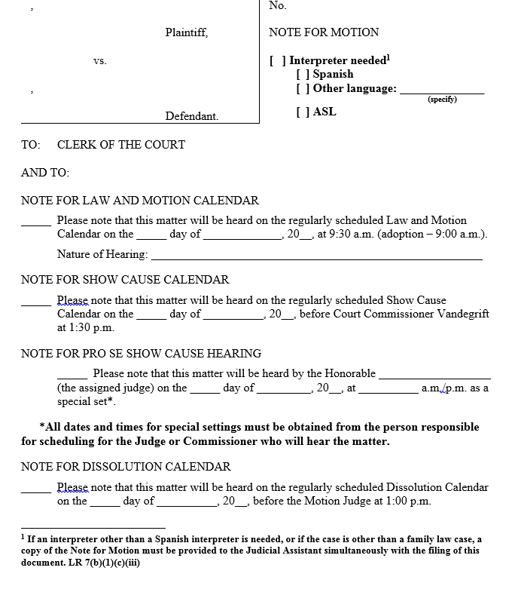
7/25/11 | Clallam | Generally we do. We get a lot of last minutes requests where we end up using the language line.
9/14 | Clark | Does provide interpreters in civil/domestic cases. There is information regarding how to request on the website (http://www.co.clark.wa.us/courts/interpreter.html) and also signs posted in the courthouse in multiple languages.  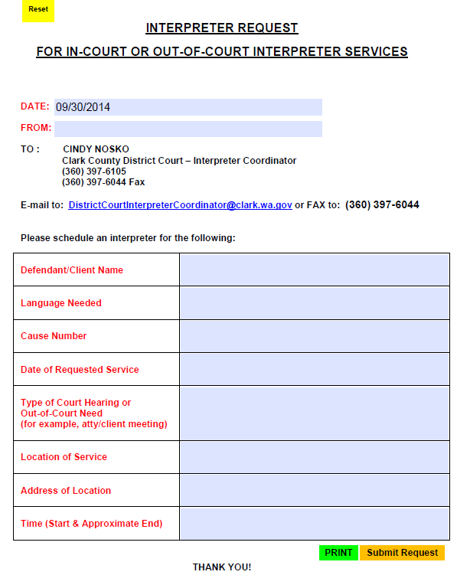
7/25/11 | Douglas | Yes, we are. Have done so always. Follow up response to my question “In civil cases?: Yep, in civil cases where we know ahead of time an interpreter is needed. It’s easier that way for the Court.
9/14 | Island | Yes – once we are notified, either by the person or the attorney, we contact the Language Exchange to schedule an interpreter for the hearing regardless of ability to pay. We have signage posted in the lobby (from AOC, multiple languages) and at our counter for information regarding language assistance.
9/14 | Jefferson | Jefferson County provides an interpreter when the need is brought to the Court’s (or Clerk’s) attention. They use “I Speak” cards at the front counter. They use both tele-interpreters and in-person interpreters depending on the type and length of hearing and how much notice they have in scheduling time.
9/14 | King | King County Superior Court provides ASL and foreign spoken language interpreters in all civil cases. This includes not only court hearings but also any ancillary events such as working with Facilitators, Protection Order Program personnel, court social workers, Housing Justice Project for evictions and instructors of mandatory parenting classes, to name a few.  Information regarding the availability of interpreter services is included in the court’s and DJA’s website through a link to the Office of Interpreter Services (OIS) and court staff have been trained to direct individuals to OIS. The Department of Judicial Administration utilizes Language Line to assist customers at their counter and will provide them information on OIS, they also have pamphlet regarding OIS in five languages (Spanish, Chinese, Somalian, Russian and Vietnamese). The OIS website has instructions in eight languages (Arabic, Chinese, Korean, Laotian, Russian, Spanish, Tagalog and Vietnamese) in addition to English. Limited English Proficient (LEP) persons enter the courthouse where there may not be adequate signage in other languages, or they are not literate, and so do not know where to go to find offices/services. To assist in remedying the situation, KCSC is embarking on a pilot project: The installation of a touch screen kiosk in the KCCH lobby, with the possibility of expanding to audio capability and other KCSC sites. The LEP person will touch their language (starting with the top 6) on the screen and will be directed to responses based on their needs and information they are seeking.  The court is made aware of the need through referrals generated by court personnel and requests from the non-English speaker or their attorney or family members. Once services have been provided by OIS, future events are tracked to be sure an interpreter is scheduled for the next court event.  Link to Interpreter Services for King County Superior Court - http://www.kingcounty.gov/courts/SuperiorCourt/InterpSrv.aspx
9/14 | Kitsap | We do in Kitsap, also, when we are made aware of the need.  We have hung one of the AOC laminated signs in Ct Admin Reception. We have also provided one to our Jail booking area. I just took a walk and was surprised to see a similar sign was not hung in either our Clerk’s Office or our Facilitator’s Office. Clearly, we have work to do. We also still have “I Speak” cards available in courtrooms and at the front desk to assist us in determining what language(s) is necessary.  Typically, the Clerk’s Office staff, the Facilitators, and/or judicial officers will refer LEP people to administration to talk with me or our Court Scheduler to make sure we are aware of the need. Our scheduler normally makes arrangements w/for the interpreter(s) since we’re paying for it.
9/14 | Lewis | Yes for Lewis County—at no charge
9/14 | Mason | We provide interpreters for all hearings and trials if needed. Usually we are notified by the clerk or attorneys. We have the AOC language poster, and there is also a place on our note for hearing form to indicate if an interpreter is needed.  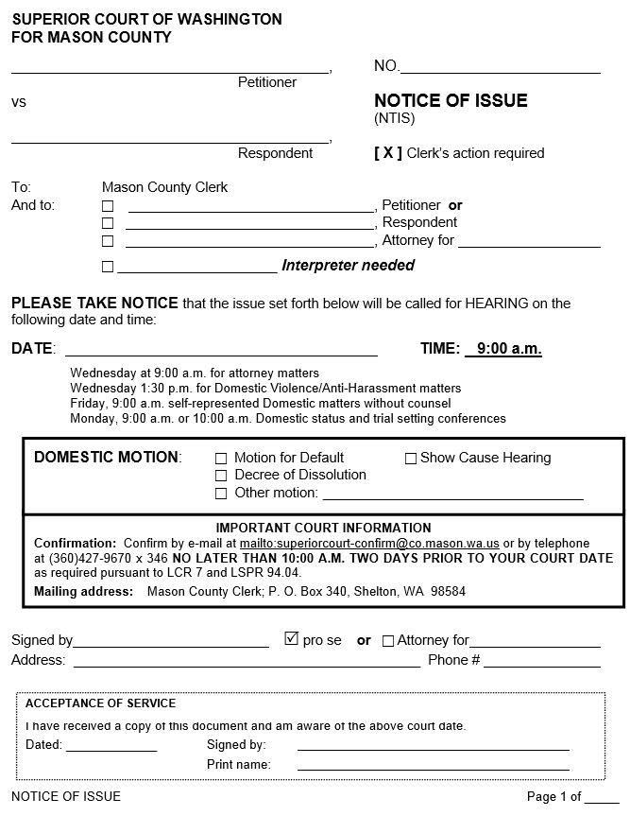
7/25/11 | Okanogan | We do in Okanogan.
9/14 | Pierce | It has been Pierce County Superior Court policy since 2011 that we provide interpreter services for all limited English proficient (LEP) and hearing-impaired persons in all court hearings and court-ordered functions without distinguishing among criminal, civil or administrative matters. In addition to the information on our interpreter web page (http://www.co.pierce.wa.us/index.aspx?NID=1033), AOC signage “You may have the right to a court-appointed interpreter in a court case. Please ask someone at the court information desk” is posted at the following locations:  1) 1st and 2nd floor public entrances to the County-City Courthouse Building.  2) Public entrances to Remann Hall Juvenile Center.  3) Court administrative reception office windows for Superior, District and Juvenile Courts.  4) Pierce County Interpreter Services Office.  Finally, court personnel and judges may determine that an interpreter is appropriate for a court hearing and informs the Interpreter’s Office.
9/14 | Skagit | Skagit County provides interpreters for all court hearings or trials when requested. We’ve received a legal opinion from our civil prosecutor advising us to do so.  Skagit does the following: multilingual poster(s) hang on the first and second floors of the Courthouse (including the Law Library); the Language Identification Flashcard (from the U.S. Census Bureau) is readily available in Court Administration; forms to request an interpreter are on-line (see below screen print of website); hard copy forms are placed in multiple areas around the Courthouse (Clerk’s Office, Facilitators’ Office, Law Library, Superior Court Administration);  front counter employees, in all departments of the Courthouse, will refer people to Court Administration staff  In Skagit County, we will receive an email from another department (i.e. Juvenile, Public Defender, Prosecutor) with the request, a Courthouse employee will offer assistance and then send the litigant to Court Administration, and local agencies (like Skagit Community Action) will contact us (person is coming on our ex parte calendar for a temporary restraining order and needs an interpreter).  This form is available in English & Spanish:  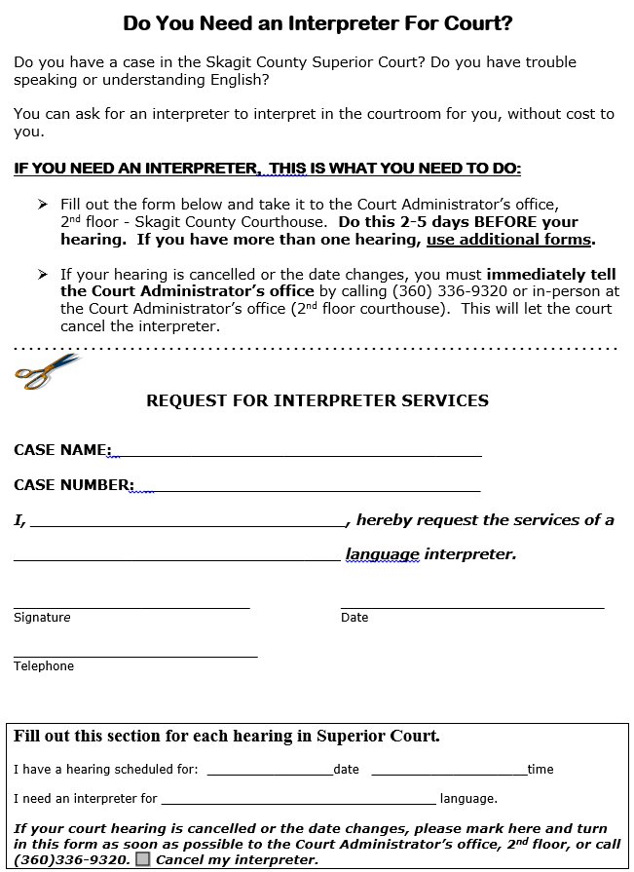
7/25/11 | Snohomish | The policy of the Snohomish County bench is as set forth below:  Eligibility for Interpreter Services  Court Administration will approve services for any person who is a participant in the proceeding by virtue of having been subpoenaed, summoned, or otherwise compelled by the court to appear.  In civil preceding the cost of providing the service is the responsibility of the non-English speaking person, unless the person is indigent and demonstrates indigence to Court Administration.  If the court requests an interpreter be assigned to a case, the court will pay the interpreter fees.  “Impaired person” means a person who, because of hearing or speech impairment, cannot readily understand or communicate a spoken language; and includes persons who are deaf, deaf and blind, speech impaired, or hard of hearing.  “Non-English-speaking person,” means any person involved in a legal preceding that cannot readily speak or understand the English language.  We provide ASL interpreters as an ADA accommodation in all case types.  In addition, judges have made decisions to provide interpreters in civil cases on a case by case basis.
9/14 | Spokane | Yes, we recently revised our interpreter policy to comply with correspondence from Jeff Hall and Mr. Perez.  (update) There is signage in the courthouse, court staff know to advise, and there information on the website regarding how to obtain an interpreter. The court is generally made aware of the need for an interpreter through attorneys, court staff, litigants requesting via the website/in person/telephonic.  *  *  *  Spokane con’t…  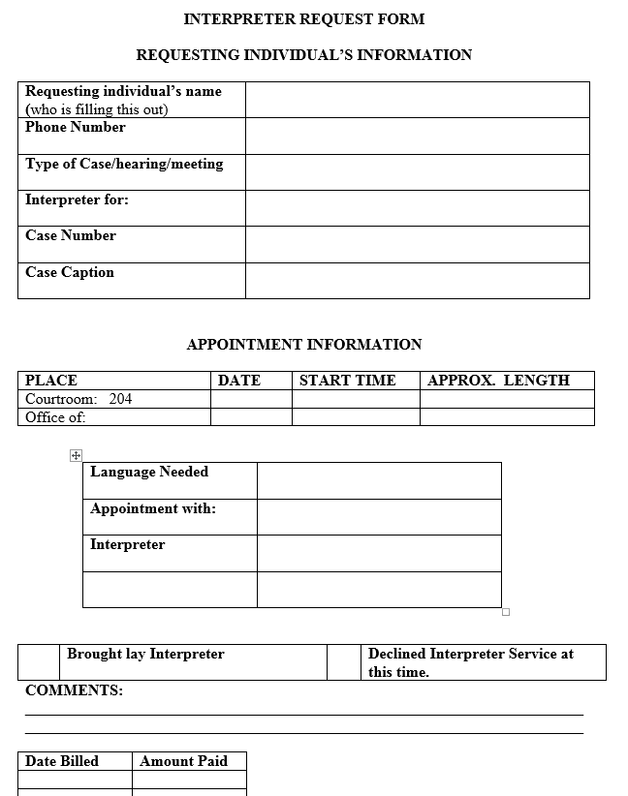  There are a couple of forms associated with interpreter requests (found here http://www.spokanecounty.org/superiorcourt/content.aspx?c=1065) but they are in English.
7/25/11 | Thurston | We are struggling. We do for all defendants charged with a crime, parent(s) in dependency actions and civil protection order matters. We've opened the door further by providing no cost services to family court litigants with a finding of indigency on file. This is going to be a topic for discussion at this week's judges meeting based on the article in last Friday's Judicial Clippings.
7/25/11 | Whatcom | We are and have been for a while.

